Logistics Resilience task force
Paperless logistics QWDT
RFI application form
Contents
1. Introduction & timing 3
2. Contact information 3
3. description 4
3.1. Description of the QWDT functionality offered 4
3.2. Description of the setup requirements for this QWDT 4
3.3. Your standard market rate and T&C’s for this QWDT 4
3.4. Timeline and Action Plan for this QWDT 4
3.5. Your relevant experience and references to previous projects. 4
3.6. Compliance of the QWDT with regards to legal registration 4
4. Contact 5

Introduction & timing
This application form for the Quick Win Digital Tool [QWDT] for a Paperless Logistics solution should be sent latest on 22 May 2020 by e-mail to eric.verlinden@vil.be .
Evaluation and selection will be planned for 28 May 2020 and formalized in the Resilience Task Force meeting that same day.
The applicants will be informed about the decision latest 29 May 2020 at 17:00 after which practical arrangements will be made to launch the information campaign with the selected applicants.
Any relevant additional functionality or tool(set) that the applicant wishes to share can be provided as separate attachments.
All provided documents, including this application form, must be in PDF format.
Non-conformances will result in not admitting the application.

Contact information
Company:
- Official name :
- Legal form :
- Official address :
- VAT Nr :
- Website :

Personal:
- Name + first name :
- Email :
- Phone / Mobile nr :

description

Description of the QWDT functionality offered
<Please complete this section with a concise but clear description of the tool and its functionality, preferably documented with relevant screenshots of this solution>

Description of the setup requirements for this QWDT
<Please complete this section with a concise but clear description>

Your standard market rate and T&C’s for this QWDT
<Please complete this section with a clear pricing overview and Terms & Conditions>

Timeline and Action Plan for this QWDT
<Please complete this section with a graphical timeline and bullet-point Action Plan for this solution>

Your relevant experience and references to previous projects.
<Please complete this section with a concise but clear description>

Compliance of the QWDT with regards to legal registration
<Please complete this section with a concise but clear description of your compliancy and legal registration (i.e. digital signature) and data (i.e. GDPR and digital archive) >

Contact
Eric Verlinden, Manager Transition

eric.verlinden@vil.be

+32 3 229 05 33 / +32 477 33 67 68

VIL ● Koninklijkelaan 76 ● B-2600 Berchem
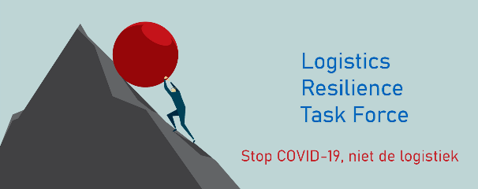
www.vil.be

